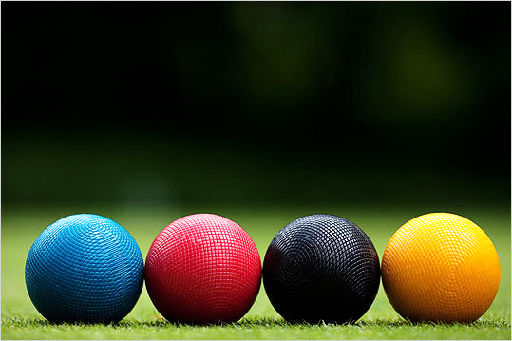
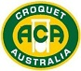

Sunsmart Policy

AUSTRALIAN CROQUET ASSOCIATION SUNSMART POLICY
The following policy has been developed to assist Croquet players with minimising the risk of overexposure to Ultra Violet Rays (UVR).

Rationale
Australia has one of the highest rates of skin cancer in the world. Of all the cancers diagnosed in Australia each year, 80 percent are skin cancers. Too much exposure to the sun can cause sunburn, skin damage, eye damage and skin cancer. Given that most sporting events are conducted during the peak UVR times, it is important that sports organisations create an environment where Sun Smart polices are positively encouraged.

People often experience sunburn and skin damage when participating or watching sport due to extended periods of being exposed to high levels of UV without appropriate protection from the sun.

Taking into account these facts, The Australian Croquet Association (ACA) realises the needs to protect participants, organisers, officials, coaches and spectators from exposure to UV and educate them about Sun Smart behaviour and therefore reduce the risk of skin damage.

Aims
The policy aims to:
- Provide ongoing education that promotes personal responsibility for skin cancer prevention and early detection.
- Provide participants and spectators with an environment that supports SunSmart practices
- Create an awareness of the dangers of exposure to UVR and the methods that can be used to prevent this damage.
- Ensure that the SunSmart policy is passed onto all State organisations and clubs as well as being available to anyone involved in the sport of Croquet via the ACA website.

Sun Protection Methods

- Clothing
- Where possible The Australian Croquet Association recommends players and officials wear sun-protective clothing wherever possible.
- ACA recommends players and officials to wear long sleeve shirts that are made from UPF (UV protection factor) 50+ material.

- Sunscreen
- Players and officials are reminded to ensure that any exposed skin should have SPF 30+ sunscreen applied at all times.
- ACA recommends the use of water resistant, SPF 30+ broad spectrum, sunscreen at all times when exposed to UVR.
- Participants are encouraged to apply sunscreen 20 minutes before being exposed to the UV and reapplying every two hours.
- It is recommended that all sunscreen be stored below 30 degrees and replaced once it past the expiry date.
- Where practical all venues should have SPF 30+ sunscreen available for all members to use.

- Hats
- The wearing of hats is to be encouraged. Preferably wide-brimmed hats are included as part of the team uniform. A wide brimmed hat provides better protection than a cap or visor which do not provide adequate protection to the face, ears and neck.

- Shade
- When not involved in an event or between competition, participants should use all available shaded areas.
- Provide suitable temporary shade structures for events where there is inadequate permanent facilities.
- A number of State Governments now offer grants to sporting and community organisations to provide shade facilities. For example: http://sport.vic.gov.au/news-media/news/shade-grants-sports-clubs

- Sunglasses
- ACA recommends that all players, officials and spectators wear sunglasses that meet Australian Standard for UV protection.

- Night Play
- While not all clubs have facilities with lighting, ACA encourages where possible matches be staged at night to avoid harmful effects of UVR.

Education and Information
- Inform individuals when they apply for membership about our SunSmart program.
- ACA members are encouraged to access the free SunSmart app.
- Visit the SunSmart http://www.sunsmart.com.au/ website for more information.
- Promote SunSmart behaviour at ACA events through posters and information brochures.
- Regularly reinforce ACA SunSmart policy via the organisations website and social media platforms.

Review
- Annually undertake a review of the SunSmart policy to ensure it remains current.
- Last reviewed 10th May 2018.

