Report to be completed by person involved or Management Committee Member if person is incapacitated.

Section 1: Person’s details (Who was involved?)

Family name |  | First name
Address |  | Contact Number
Were other people involved? | Please Tick YES NO | List name/s | 1.  2.  3.
Address/es | 1.  2.  3. | Contact Number/s | 1.  2.  3.
Do they need follow up support? | Please Tick YES NO | Next of Kin name &  contact

Near miss (a dangerous incident without injury to person or damage to property). Go to Section 2 Accident (an incident resulting in injury to a person or damage to property). Complete Sections 2,3 & 4

Section 2: Incident details (when, where & what happened?) Attach an extra page if necessary.

Club Name |  | Activity (competition, training, event, other)
Club Address |  | Code/Discipline
When did this incident happen? | Date: / / Time: am/pm | Reported to? | Name:  Date: / /
Describe the Incident
(What happened?)
Where did it happen? (on a lawn, during game, before or after a game, at Clubhouse? Provide details)
Describe how it happened
Why do you think it happened? Was it preventable?
(what, if any, controls can be implemented to help ensure the incident doesn’t happen again?)

Section 3: Witnesses

Were there any witnesses to the injury? | Please Tick YES NO
If yes, please list the witnesses’ full name/s as well as a contact number for each.

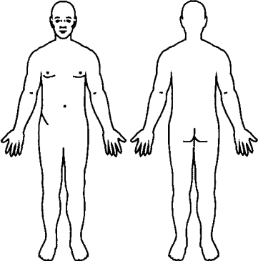
Section 4: Injury and Medical

Describe the injury
Describe and mark on diagram bodily location of injury OR list any damage to property

Was any first aid provided? | Please Tick YES NO
If yes, please provide details.
Did the injured person require an Ambulance? | Please Tick YES NO
Was the injured person transported to Hospital? | Please Tick YES NO

Section 5: To be completed by the Investigating Officer

Has an investigation been conducted into the incident and by who? |  | Please Tick YES NO
Name of the person who conducted the investigation.
Have the controls been implemented? | Please Tick YES NO |  | Date / /
Should this report be referred to the ACA CEO and/or Board? | Please Tick YES NO
Signature & Date |  | Date / /

Email completed form to admin@croquet-australia.com.au or contact the ACA Administrative Officer on 0457 678 380.
If the matter is an emergency call triple zero.

